Lab 4

Team Awesome (19) - Sayem Lincoln, Joshua Schwimmer, John Townshend.

3/30/2020

#Ex 1

#Question 3 Answer - Additive

plot(conf_mat_50_additive)

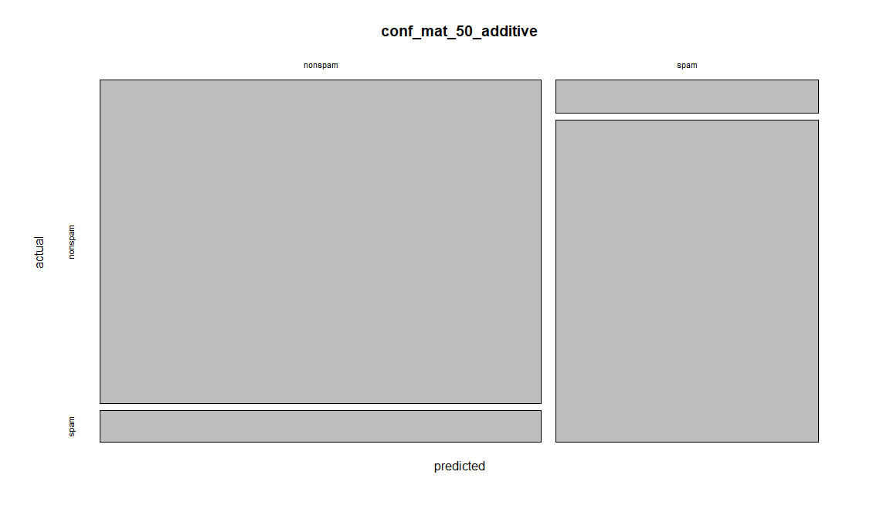

Over

plot(conf_mat_50_over)

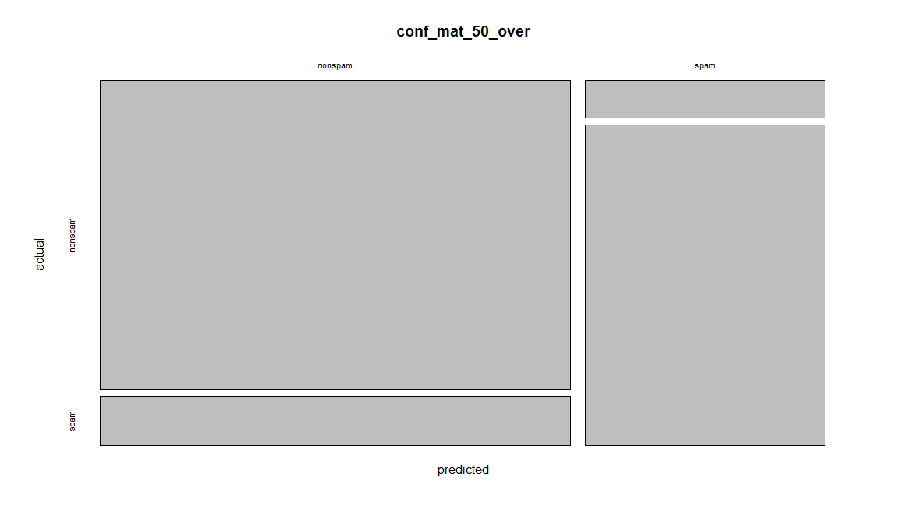

Selected

plot(conf_mat_50_selected)

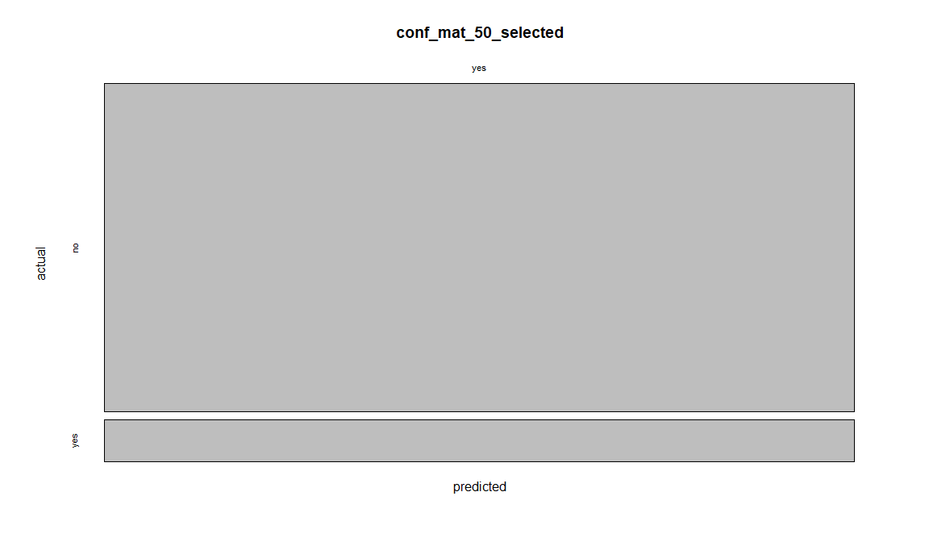

Caps

plot(conf_mat_50_caps)

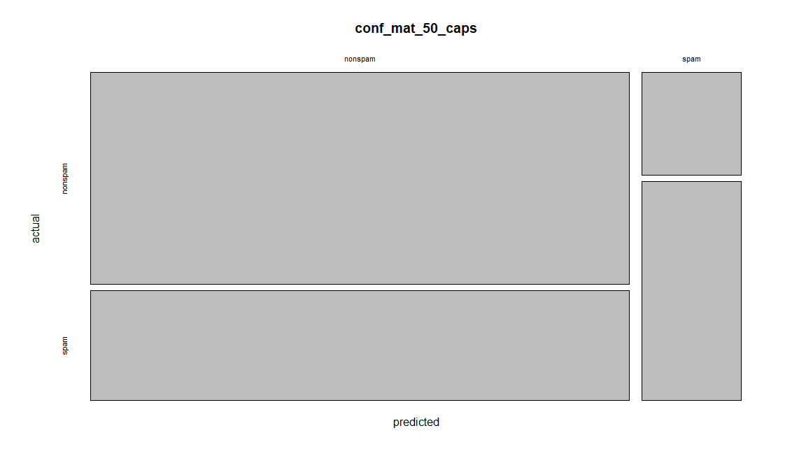

#Question 4 Answer - The best model is the additive model, because it gives us the highest amount of nonspam across actual and lowest amount across predicted, and does the opposite when it comes to spam; we get the lowest amount of spam across actual and highest across predicted. The reason this is better because at times which email is spam and which is nonspam isn’t well defined, so through this model the user will be notified about which email is which and then the model will learn from it, but initially the model takes into account that the predicted proption of email for nonspam will be low and spam will be high, as such is the case for most general email users. But as then the model gets trained it adjusts and gives out a new output.

#Ex 2

#Question 3 Answer - The coeffecient of defaultyes is 0.01485119, has a positive coefficient, which means it contributes more to y=yes. The coeffecient of Intercept is -1.549455, has a negative coefficient, which means it contributes more to n=no. The coeffecient of housingyes is -0.7367096, has a negative coefficient, which means it contributes more to n=no. The coeffecient of loanyes is -0.8473235, has a negative coefficient, which means it contributes more to n=no.

#Question 4

plot(conf_mat_50_selected)

